**1.       Model Summary**

This rates model is intended to exploit the difference between economic conditions and market pricing. The model has been built for the United States, Canada, Australia and the United Kingdom.

**2.       Signal Performance**

**Chart 1: equity curve since 1990 (net tran cost)**

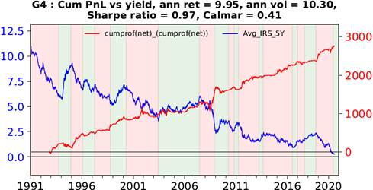

**Table 1: Metrics**

|  |  |  |  |
| --- | --- | --- | --- |
| **Sample period** | **Full sample (since 1990)** | **Since 2010** | **YTD** |
| **Return(net)** | 9.9% | 11.1% | 20.3%(YTD) |
| **volatility** | 10.3% | 9.0% | 12.0% |
| **sharpe** | 0.97 | 1.24 | 1.7 |
| **annualized cost (bps)** | 25 | 36 | 70 |
| **max drawdown** | 24.0% | 11.5% | 11.5% |
| **calmar** | 0.41 | 0.97 | 1.77 |

**Chart 2: Performance per asset (without volatility adjustment):**

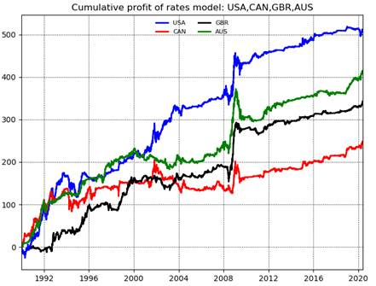

**Table 2: Full sample metrics (since 1990)**

|  |  |  |  |  |
| --- | --- | --- | --- | --- |
| **Country** | **USA** | **GBR** | **CAN** | **AUS** |
| **Return(net)** | 1.6% | 1.2% | 0.8% | 1.3% |
| **Volatility** | 2.3% | 1.5% | 1.8% | 2.0% |
| **Sharpe** | 0.7 | 0.8 | 0.4 | 0.7 |
| **Annualized cost (bps)** | 0.7 | 1.8 | 3.3 | 4.6 |
| **Max drawdown** | 5.1% | 4.3% | 8.2% | 7.8% |
| **Calmar** | 0.3 | 0.3 | 0.1 | 0.2 |

**Table 3: Recent sample metrics (since 2010)**

|  |  |  |  |  |
| --- | --- | --- | --- | --- |
| **Country** | **USA** | **GBR** | **CAN** | **AUS** |
| **Return(net)** | 0.8% | 0.7% | 0.7% | 1.0% |
| **Volatility** | 0.9% | 0.8% | 0.8% | 1.2% |
| **Sharpe** | 0.86 | 0.8 | 0.9 | 0.9 |
| **Annualized cost (bps)** | 0.6 | 1.4 | 2.8 | 4.3 |
| **Max drawdown** | 2.1% | 1.7% | 1.1% | 1.4% |
| **Calmar** | 0.4 | 0.4 | 0.7 | 0.7 |

**Table 4: YTD metrics**

|  |  |  |  |  |
| --- | --- | --- | --- | --- |
| **Country** | **USA** | **GBR** | **CAN** | **AUS** |
| **YTD return(net)** | -0.14% | 3.4% | 2.2% | 4.1% |
| **Volatility** | 1.74% | 1.1% | 1.6% | 1.8% |
| **Sharpe** | -0.1 | 3.3 | 1.4 | 2.3 |
| **Annualized cost (bps)** | 1.9 | 3.3 | 7.8 | 6.9 |
| **Max drawdown** | 1.8% | 0.4% | 0.9% | -0.9% |
| **Calmar** | -0.1 | 8.9 | 2.3 | 4.6 |

**3.       Correlation with CI**

Correlation report between Rates Fair Value - 5y and CI  
  
Full Sample correlation: **0.09**  
Jan'08 - Jun'17 correlation: **0.11**  
Jul'17 - Feb'20 correlation: **0.03**  
  
Please see correlation below:  
- correlation per quantile table  
- rolling returns chart  
- cumulative returns chart  
- rolling 1y returns chart  
  
  
**Correlation per return Quartile:**

|  |  |  |  |
| --- | --- | --- | --- |
|  | **CI Avg** | **Rates Fair Value - 5y Avg** | **Corr Avg** |
| **Bottom CI 3m Return Quartile** | -2.80 | 1.05 | 0.05 |
| **2nd** | 0.83 | 1.46 | -0.04 |
| **3rd** | 3.29 | 3.35 | 0.09 |
| **Top CI 3m Return Quartile** | 8.05 | 6.18 | 0.01 |

*CI 3m rolling performance is split into 4 quartiles. The table shows the averages of the 3m rolling returns and 3m rolling correlations conditional on CI 3m rolling return being in the respective quartile.*

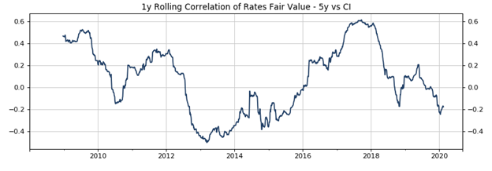

**4.       Sensitivity analysis**

**Delaying execution**

**Chart 4**

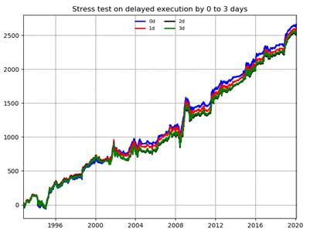

**Table 5**

|  |  |  |  |  |
| --- | --- | --- | --- | --- |
| **Delayed days** | **0d** | **1d** | **2d** | **3d** |
| **Return(gross)** | 9.74% | 9.55% | 9.36% | 9.44% |
| **Volatility** | 10.56% | 10.54% | 10.55% | 10.55% |
| **Sharpe** | 0.92 | 0.91 | 0.89 | 0.89 |
| **Annualized cost (bps)** | 34 | 34 | 34 | 34 |
| **Max drawdown** | 22.7% | 23.6% | 26.1% | 24.5% |
| **Calmar** | 0.43 | 0.40 | 0.36 | 0.39 |

**Lagging non-market data signals.**

**Chart 5**

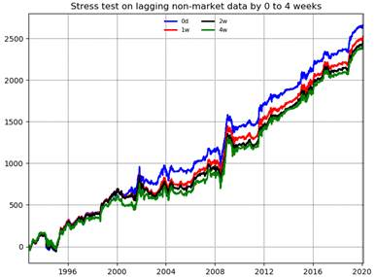

**Table 6**

|  |  |  |  |  |
| --- | --- | --- | --- | --- |
| **Lagging periods** | **0d** | **1w** | **2w** | **4w** |
| **Return(gross)** | 9.74% | 9.23% | 9.00% | 8.86% |
| **Volatility** | 10.56% | 10.54% | 10.52% | 10.54% |
| **Sharpe** | 0.92 | 0.88 | 0.86 | 0.84 |
| **Annualized cost (bps)** | 34 | 32 | 35 | 33 |
| **Max drawdown** | 22.7% | 24.8% | 26.1% | 22.6% |
| **Calmar** | 0.43 | 0.37 | 0.35 | 0.39 |

**Applying minimum 10k DV01 buffer.**

**This is to execute the trades if DV01 is bigger than 10k.**

**Chart 6**

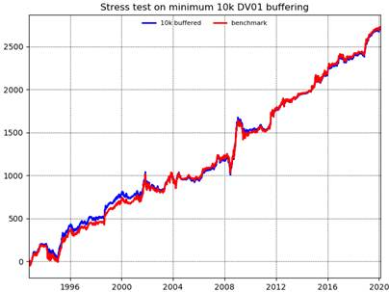

**Table 7**

|  |  |  |
| --- | --- | --- |
| **Buffering** | **10k buffer** | **Benchmark** |
| **Return(gross)** | 9.90% | 9.74% |
| **Volatility** | 10.61% | 10.56% |
| **Sharpe** | 0.93 | 0.92 |
| **Annualized cost (bps)** | 22 | 34 |
| **Max drawdown** | 22.79% | 22.70% |
| **Calmar** | 0.43 | 0.43 |

**Shocking on parameters: equal weight to all economic condition subcomponent**

**Chart 7**

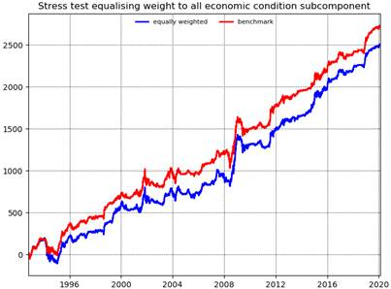

**Table 8**

|  |  |  |
| --- | --- | --- |
| **Shock** | **Eq weighted** | **Benchmark** |
| **Return(gross)** | 9.13% | 9.74% |
| **Volatility** | 10.43% | 10.56% |
| **Sharpe** | 0.88 | 0.92 |
| **Annualized cost (bps)** | 19 | 34 |
| **Max drawdown** | 30.49% | 22.70% |
| **Calmar** | 0.30 | 0.43 |

**Shocking on parameters:  increasing the transformation parameters by 50%.**

**This is to use longer transformation of input variables. For example 12m  change in CPI  -> 18m change in CPI**

**Chart 8**

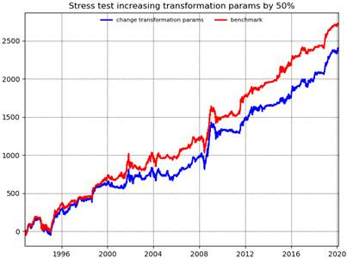

**Table 9**

|  |  |  |
| --- | --- | --- |
| **Shock** | **Increase transformation length** | **Benchmark** |
| **Return(gross)** | 8.73% | 9.74% |
| **Volatility** | 10.63% | 10.56% |
| **Sharpe** | 0.82 | 0.92 |
| **Annualized cost (bps)** | 19 | 34 |
| **Max drawdown** | 22.20% | 22.70% |
| **Calmar** | 0.39 | 0.43 |

**Using unrevised data**

**This is to use the “first” data from EconDB.**

**Chart 9**

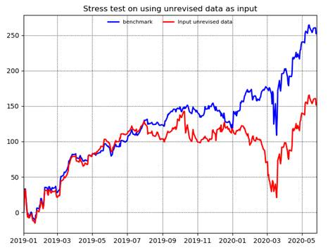

**Table 10: sample period: since 1/1/2019**

|  |  |  |
| --- | --- | --- |
| **Input** | **Unrevised data** | **Benchmark** |
| **Return(gross)** | 9.9% | 17.0% |
| **Volatility** | 9.0% | 9.9% |
| **Sharpe** | 1.1 | 1.71 |
| **Annualized cost (bps)** | 61 | 43 |
| **Max drawdown** | 12.5% | 6.9% |
| **Calmar** | 0.8 | 2.4 |

**5.       Model Construct**

The model works by creating an aggregate measure of the economy’s health based on combining common economic time series. The model works largely because it is able to collapse economic information into a reasonable estimate of aggregate economic activity in a way that is challenging for any one person looking at disparate time series.

For the purpose of creating transparency and structure (as opposed to simply averaging multiple time series directly), we have created a number of buckets that describe key concepts in the economy. We then average the buckets to obtain a final measure of economic health. The weights chosen are logical, rather than optimized.

The mathematical method used to combine economic time series that exist in different spaces is to first convert the time series into a Z-score. Once series are in Z-score form, they can be averaged.

**Order of Construction:**

Step 1: Take economic time series and transform them in such a way as to have meaning over the medium term. E.g. the 3 month change in 12 month inflation will pick up whether inflation is rising or falling. Key is to strike a balance between getting a fast read on what is happening economically and avoiding choppy time series that have little descriptive power.

Step 2: Take a z-score of each time series so that all time series are normalized.

Step 3: Assign the economic statistics in step 2 into buckets and create a “Gauge” to reflect the aggregate of the times series. This aggregate should meaningfully reflect a key economic concept such as Capacity, Economic Change…

The buckets we have used are meant to answer the following questions (please see appendix for detail on the inputs):

**Levels:**How tight is the economy?

**Growth vs Potential:**How fast capacity is changing?

**Changes:**Is the economic activity accelerating or decelerating?

**Forward Growth:**Would you expect growth to be rising or falling in the next period?

**Forward Inflation:**Would you expect inflation to be rising or falling in the next period?

**Credit/Housing:** How frothy are domestic non-financial markets?

**Global Conditions:** How strong are trading partners?

Step 4: Combine these measures of economic activity into one measure, a Conditions Gauge. This measure should be a reasonable assessment of if the central bank should be looking to ease or tighten. Below is an example for USA:

**Chart 10**

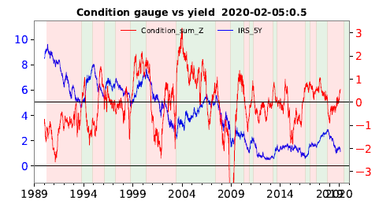

Step 5: Create a measure that accounts for what the market is discounting. We calculate the Z of front end rate curve steepness (2y1m swap less 1w swap). When calculating the Z we use a zero mean and subtract a risk premium of 20 bps to take the beta-compensation out of the curve. Below is an example for USA:

**Chart 11**

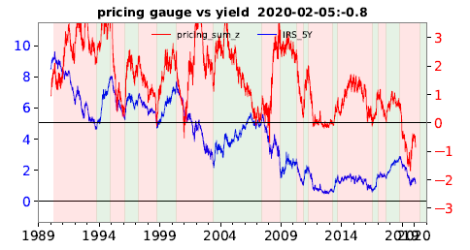

Step 6: Take the difference in the Conditions gauge and Pricing gauge. We assign a 70% weight to conditions and a 30% weight to pricing.

This produces the final signal:

**Chart 12**

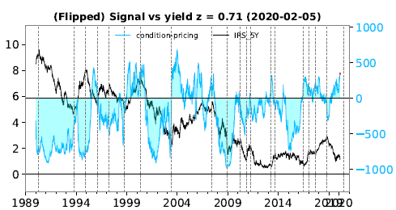

Step 7: perform 3 stages volatility scaling to reach the target vol on the portfolio level:

i.                    Scale the position for each individual country so that the volatility on that country reaches the target vol over the medium term. At this stage the correlation between each basket is not taken into consideration.

a.       Volatility scaling factor = target vol/ instrument ‘s 2 year rolling std.

b.      Scaled return on each country = unscaled return * volatility scaling factor

c.       Scaled portfolio return = sum of scaled return on each country

ii.                  Rescale the position on the overall portfolio so that the portfolio reaches the target vol in the medium term.

a.       Portfolio rescaling factor = target vol/scaled portfolio 2 year rolling std

b.      Total scaling factor for each country = volatility scaling factor*portfolio rescaling factor

iii.                Apply cap on the position if the expected volatility in the short term spike over the limit.

a.       Estimate the var-cov matrix using expected volatility and correlation:

                                                              i.      Expected short vol = (1y vol+3m vol+ 3m implied vol)/3

                                                            ii.      Expected correlation = 5 year weekly correlation

                                                          iii.      Expected volatility = weights for instrument today * expected correlation * expected volatility

b.      If expected volatility >2, the volatility cap factor = 2/expected volatility

c.       Total scaling factor for each country after cap = Total scaling factor for each country* volatility cap factor

iv.                 Signal after vol adj = raw signal * total scaling factor after cap

v.                   DV01 = -Signal after vol adj * instrument’s duration

vi.                 Apply transaction cost reduction algorithms:

a.       Inertia

b.      DV01 cap

**6.       Appendix**

6.1 Below are the inputs and weights for each country. Weights are risk weights given that they are used to average time series that are in Z-space.

**USA:**

|  |
| --- |
| Gauge tree |
| Condition minus pricing, |
| ├── Pricing gauge, weight = 0.3 |
| │   ├── Pricing gauge, weight = 0 |
| │   └── Pricing gauge, steepness between 2y1d and 1w ois, weight = 1.0 |
| └── Condition gauge, weight = 0.7 |
| ├── Level gauge, weight = 1.0 |
| │   ├── GDP slack, weight = 1.0 |
| │   ├── Unemployment vs trend, weight = 1.0 |
| │   ├── Capacity vs trend, weight = 1.0 |
| │   ├── Wage tracker vs trend, weight = 2.0 |
| │   │   ├── Wage(nfp) vs trend, weight = 2.0 |
| │   │   ├── Wage(atlanta) vs trend, weight = 1.0 |
| │   │   ├── Wage(eci) vs trend, weight = 1.0 |
| │   │   ├── Wage(bls median) vs trend, weight = 1.0 |
| │   │   └── Wage(comp hour nonfarm) vs trend, weight = 1.0 |
| │   ├── Cpi(GS tracker) vs target, weight = 1.0 |
| │   └── BEI5 vs target, weight = 1.0 |
| ├── Growth minus potential, weight = 2.0 |
| │   └── Growth vs potential, weight = 1.0 |
| ├── Change gauge, weight = 3.0 |
| │   ├── Change in growth, weight = 4.0 |
| │   ├── Change in citi econ chg index, weight = 0 |
| │   ├── Change in wage (tracker), weight = 4.0 |
| │   │   ├── Change in wage(nfp), weight = 2.0 |
| │   │   ├── Change in wage(atlanta), weight = 1.0 |
| │   │   ├── Change in wage(eci), weight = 1.0 |
| │   │   ├── Change in wage(bls median), weight = 1.0 |
| │   │   └── Change in wage(comp per hour nonfarm), weight = 1.0 |
| │   ├── Change in cpi pce, weight = 1.0 |
| │   ├── Change in surprise in cpi, weight = 1.0 |
| │   ├── Change in cpi GStracker, weight = 0 |
| │   └── Change in bei5, weight = 1.0 |
| ├── Credit aggregate, weight = 2.0 |
| │   ├── Housing_price_1st, weight = 2.0 |
| │   ├── Housing_price_2nd, weight = 1.0 |
| │   ├── Credit_flow_ngdp, weight = 1.5 (also see 6.3) |
| │   └── Credit_impulse_ngdp, weight = 1.5 (also see 6.3) |
| ├── Forward growth, weight = 4.0 |
| │   └── In-house growth estimate / Fiscal Impulse, weight = 6.0 |
| ├── Forward cpi, weight = 1.0 |
| │   ├── Oil_impulse_1st, weight = 1.0 |
| │   ├── FX_impulse_1st, weight = 1.0 |
| │   ├── Oil_impulse_2nd, weight = 1.0 |
| │   └── FX_impulse_2nd, weight = 1.0 |
| └── Global gauge, weight = 1.0 |
| ├── Glob growth pot, weight = 1.0 |
| ├── Glob FCI impulse, weight = 1.0 |
| └── Glob change in growth, weight = 2.0 |

**CAN:**

|  |
| --- |
| Condition minus pricing, |
| ├── Pricing gauge, weight = 0.3 |
| │   └── Pricing gauge, steepness between 2y1d and 1w ois, weight = 1.0 |
| └── Condition gauge, weight = 0.7 |
| ├── Level gauge, weight = 1.0 |
| │   ├── GDP slack, weight = 1.0 |
| │   ├── Unemployment vs trend, weight = 1.0 |
| │   ├── Capacity vs trend, weight = 1.0 |
| │   ├── Wage vs trend, weight = 1.0 |
| │   └── Cpi(trimmed) vs target, weight = 2.0 |
| ├── Growth minus potential, weight = 2.0 |
| │   └── Growth vs potential, weight = 1.0 |
| ├── Change gauge, weight = 3.0 |
| │   ├── Change in growth, weight = 1.0 |
| │   ├── Change in citi econ chg index, weight = 1.0 |
| │   ├── Change in wage, weight = 1.0 |
| │   └── Change in cpi (trimmed mean), weight = 1.0 |
| ├── Forward growth, weight = 4.0 |
| │   └── In-house growth estimate (6m)/ Fiscal Impulse, weight = 10.0 |
| ├── Credit aggregate, weight = 2.0 |
| │   ├── Housing_price_1st, weight = 2.0 |
| │   ├── Credit_ngdp_1st, weight = 2.0 |
| ├── Forward cpi, weight = 1.0 |
| │   ├── Oil_impulse_1st, weight = 1.0 |
| │   ├── FX_impulse_1st, weight = 1.0 |
| └── Global gauge, weight = 1.0 |
| ├── Glob growth pot, weight = 2.0 |
| ├── Glob FCI impulse, weight = 1.0 |
| └── Glob change in growth, weight = 2.0 |

**GBR:**

|  |
| --- |
| Condition minus pricing, |
| ├── Pricing gauge, weight = 0.3 |
| │   └── Pricing gauge, steepness between 2y1d and 1w ois, weight = 1.0 |
| └── Condition gauge, weight = 0.7 |
| ├── Level gauge, weight = 2.0 |
| │   ├── GDP slack, weight = 1.0 |
| │   ├── Unemployment vs trend, weight = 1.0 |
| │   ├── Capacity vs trend, weight = 1.0 |
| │   ├── Wage (regular pay) vs trend, weight = 1.0 |
| │   └── Core cpi vs target, weight = 3.0 |
| ├── Growth minus potential, weight = 2.0 |
| │   └── Growth vs potential, weight = 1.0 |
| ├── Change gauge, weight = 4.0 |
| │   ├── Change in growth, weight = 4.0 |
| │   ├── Change in citi econ chg index, weight = 2.0 |
| │   ├── Change in wage(regular), weight = 2.0 |
| │   ├── Change in cpi (core), weight = 1.0 |
| │   └── Change in headline cpi, weight = 2.0 |
| ├── Forward growth, weight = 3.0 |
| │   └── In-house growth estimate/ Fiscal Impulse, weight = 1.0 |
| ├── Credit aggregate, weight = 2.0 |
| │   ├── Housing_price_1st, weight = 2.0 |
| │   ├── Mortgage approval pct gdp, weight = 2.0 |
| ├── Forward cpi, weight = 1.0 |
| │   ├── Oil_impulse_1st, weight = 1.0 |
| │   ├── FX_impulse_1st, weight = 1.0 |
| │   └── Headline minus core cpi, weight = 1.0 |
| └── Global gauge, weight = 1.0 |
| ├── Glob growth pot, weight = 2.0 |
| ├── Glob FCI impulse, weight = 1.0 |
| └── Glob change in growth, weight = 2.0 |

**AUS:**

|  |
| --- |
| Condition minus pricing, |
| ├── Pricing gauge, weight = 0.3 |
| │   └── Pricing gauge, steepness between 2y1d and 1w ois, weight = 1.0 |
| └── Condition gauge, weight = 0.7 |
| ├── Level gauge, weight = 1.0 |
| │   ├── GDP slack, weight = 1.0 |
| │   ├── Unemployment vs trend, weight = 1.0 |
| │   ├── Capacity vs trend, weight = 1.0 |
| │   ├── Wage vs trend, weight = 1.0 |
| │   └── Cpi(trimmed mean) vs target, weight = 2.0 |
| ├── Growth minus potential, weight = 2.0 |
| │   └── Growth vs potential, weight = 1.0 |
| ├── Change gauge, weight = 3.0 |
| │   ├── Change in growth, weight = 2.0 |
| │   ├── Change in wage, weight = 1.0 |
| │   └── Change in cpi (trimmed mean), weight = 2.0 |
| ├── Forward growth, weight = 4.0 |
| │   └── In-house growth estimate/ Fiscal Impulse, weight = 10.0 |
| ├── Credit aggregate, weight = 2.0 |
| │   ├── Housing_price_1st, weight = 2.0 |
| │   ├── Credit_ngdp_1st, weight = 2.0 |
| ├── Forward cpi, weight = 1.0 |
| │   ├── Oil_impulse_1st, weight = 1.0 |
| │   ├── FX_impulse_1st, weight = 1.0 |
| └── Global gauge, weight = 1.0 |
| ├── Glob growth pot, weight = 2.0 |
| ├── Glob FCI impulse, weight = 1.0 |
| └── Glob change in growth, weight = 2.0 |

6.2   Fiscal impulse construction

For USA, just use GS and Brooks Institute’s estimates on fiscal impulse and extend it back with smoothed change in fiscal deficit as percentage of GDP.

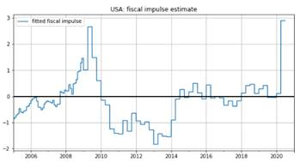

For other DM countries the estimate is performed in 3 steps:

a)      Estimate the ratio on fiscal multiplier with US. UBS research results are used as main source.

b)      Estimate the ratio on cyclically adjusted deficit with US. UBS research results are used as main source.

c)       Fiscal impulse = US fiscal impulse multiplied by results in a and b

Similar to USA, the longer history is extended back with smoothed change in fiscal deficit as percentage of GDP.

CAN:

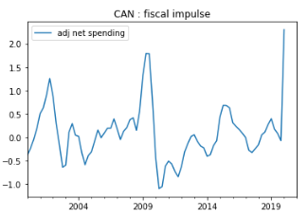

GBR:

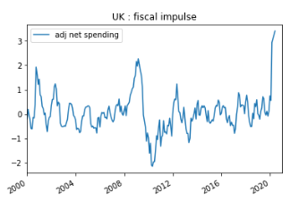

AUS:

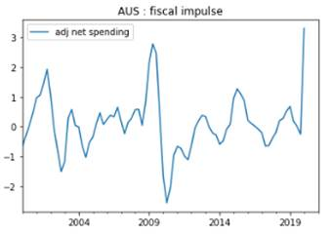

6.3   USA credit impulse

USA credit impulse is a gauge that measures:

1)      how much credit has been flowing through over a given period as % GDP

2)      how much change in credit flowing through over a given period as % GDP